**ST JOHN LLOYD CATHOLIC COMPREHENSIVE SCHOOL**

***School Mission Statement***

***“Learning and Growing Together in Christ”***

***“A Christian community which recognises the dignity and value of the***

***individual and in which all members are encouraged to develop their potential in terms of knowledge, understanding, spiritual, moral, social and cultural awareness*”.**

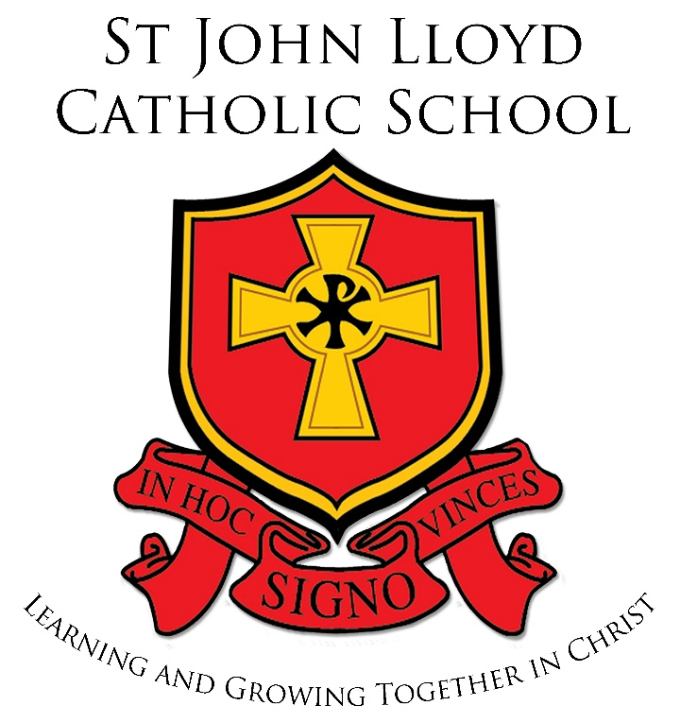

### **ADDITIONAL LEARNING NEEDS POLICY**

Approved: 30th November 2016

Reviewed: 8h October 2019

The School’s Principles and Objectives for pupils with Additional Learning Needs (ALN)

The general school aims will apply to all pupils including those with Additional Learning Needs whether they are gifted, statemented or not.

Our principal aims and values are summarised within our Mission Statement.

“Learning and Growing Together in Christ”

As a Catholic School we aim to be:

“A Christian community, which recognises the dignity and the value of the individual and in which all members are encouraged to develop their potential in terms of knowledge, understanding, spiritual, moral, social and cultural awareness.”

This means that we aim:

* To embrace the gospel values of Jesus Christ in our everyday life and work, where all can experience and grow in faith, hope, love, justice, reconciliation and service
* To value each individual with their gifts, uniquely made in God’s image.
* To challenge and support each individual to fulfil their potential as whole human persons, contributing to their spiritual, academic, physical and emotional development.
* To develop a learning community through delivering a broad, balanced and relevant curriculum, which will prepare for the opportunities and experiences of an adult life of service to others.
* To enrich the curriculum by offering opportunities in a wide range of learning experiences and by developing and strengthening links with the wider community.

The school’s objectives for pupils with Additional Learning Needs supplement the general aims as follows:

A positive constructive attitude towards ALN will be promoted and the school will establish strong working practices in the following ways;

* Good communication between primary and secondary school so transition for pupils will be as smooth and trouble free as possible.
* Early identification and assessment of ALN pupils on entering Year 7 so appropriate intervention can improve prospects and reduce the need for later intervention which will be crucial in achieving literacy and numeracy targets.
* Targets will be set and programmes of work will be built on strengths as well as addressing pupils' needs. Work will reflect the needs of the individual pupil with scope for improving achievements, with higher expectations for standards children can achieve.
* Good curriculum planning, organisation and implementation will allow pupils to follow the school curriculum, including the National Curriculum as appropriate. This will also include targets for the improvement of behaviour and the development of personal and social skills when appropriate.
* Building blocks for children with ALN will be literacy (speaking and listening reading and writing) and numeracy.
* Good parental links will be forged so that parents and pupils will have confidence in the school and be involved in decisions about their children.
* Regular monitoring and evaluation of pupils' needs will be essential in raising standards and for reviewing progress so that the quality of teaching and learning can be improved.

ALN Specialism

The ALN specialism within the school is provided by the ALN department. The department is led by the Head of Department (Additional Learning Needs Co-ordinator) who represents the department at middle management. The ALNCO is supported by a Support Teacher and Teaching Assistants.

Identification, Assessment, Monitoring and Review Procedures.

This element of the policy will be clearly defined in terms of operational policy adopted by St. John Lloyd Catholic Comprehensive School and with due regard the Code of Practice for Wales.

It will be the role of the ALNCO to co-ordinate this aspect of the policy working alongside the Deputy Head teacher.

Pupils who are thought to have Additional Learning Needs are identified and assessed as early and thoroughly as possible.

Our Equal Opportunities Policy means that all pupils are entitled to participate fully in the whole school curriculum. The school aims to provide a broad and balanced curriculum to meet the needs of all pupils. On entering the school, pupils are initially placed in mixed ability pastoral/teaching groups. Setting in various subjects is introduced later in Year 7 according to pupil need.

Key Stage 3 (Years 7 – 9)

All pupils will follow a common curriculum consisting of: Religious Education, English, Mathematics, Welsh, French, Science, Technology, Information and Communications Technology, History, Geography, Music, Physical Education, Art, Skills and Personal and Social Education.

Key Stage 4 (Years 10 –11)

All pupils follow a ‘core’ curriculum of Religious Education, English, Mathematics, Welsh, Science, Games, Personal and Social Education as well as the Welsh Baccalauriate. Pupils choose a further three subjects from the options available. These include a ranges of vocational courses offered in collaboration with Coleg Sir Gar and also includes a Curriculum Support option for pupils who may find difficulty studying three option choices.

All pupils at KS3 will complete the Welsh Government Literacy and Numeracy tests and low scores in each of these areas will indicate where extra help is needed or at least pupils that require further investigation. In year & all pupils sit a Cognitive Ability Test and discrepancies between non-verbal, verbal and reading ages also highlight specific areas for focus/attention.

Once identification, assessment and intervention have taken place, pupils and parents are kept regularly informed by a variety of means e.g. personal contact, reports and annual reviews if applicable.

ALN documents are produced by the ALN Department for all staff and this is shared on ‘Briefcase’. This offers a brief description of all pupils who hold a Statement of SEN as well as those who hold an Individual Development Plan (IDPs). It also includes other relevant ALN materials such as One Page Profiles; staff are able to download and print One Page Profiles that are relevant to the children they teach.

Assessment and Monitoring:

The initial role and responsibility is of all staff towards all ALN children. They will provide information on an individual’s experiences, achievements and difficulties. The school operates a stage approach providing written evidence at each stage. Staff refer pupils to the ALN Department via a referral form, which is included in the ALN briefcase.

Assessment and Monitoring includes:

* Continuous assessment
* Self assessment
* Reading/spelling/maths tests
* Curriculum tests
* Pupil tracking
* Pastoral/Social
* Information from Partner Agencies
* Statement / IDP review

Annual Reviews

Subject teachers are requested to send their reports electronically to the ALN Department by set dates. ALN staff gather the information and collate it into the format of ‘Educational Advice’. Specialist advice is then added. Parental opinion is sought via a standard letter. Partner agencies are also requested to send any relevant information by specific dates. The ALNCO notifies the pupil’s parents and all those involved with the child, of the review date and time and invite them to attend.

ALN Training

Professional development for teachers and Support Staff is needed if staff are to have the skills, knowledge and understanding to make a reality of raising standards for all children with ALN. In-Service training is directly related to the School Development Plan. INSET training is the responsibility of the Deputy Head teacher. The Deputy Head teacher ensures that the training needs of all staff is met. ALN training involves:

* Whole School INSET – delivered by ALNCO/LEA staff/Partner agencies
* Department INSET – delivered by ALNCO/Deputy Head teacher/Nominated Specialists
* External Professional Development e.g. specialist courses –such as ELKLAN, Fresh Start and Positive Play.

The Staged Approach:

School Action:

Triggered by teachers underpinned by evidence, relating to progress of child who despite receiving differentiated learning opportunities:

* Makes little or no progress even when teaching approaches target identified areas of weakness;
* Has difficulty developing literacy and numeracy skills thus affecting attainment in some curriculum areas;
* Presents persistent emotional and/or behavioural difficulties which do not respond to school’s behaviour management strategies;
* Has sensory or physical problems and makes little or no progress despite provision of specialist equipment;
* Has communication and/or interaction difficulties and makes little or no progress despite provision of a differentiated curriculum.

**Next Steps**

* The subject teacher completes a referral form and forwards it to the ALNCO.
* The ALNCO will then facilitate further assessment and plan future support,
* monitoring and review.
* The ALNCO will co-ordinate planning of Individual Development Plans and One page Profiles (OPPs), subject and pastoral teachers will devise strategies to deliver an individualised programme.
* Parents will be consulted and informed of action taken to help the pupil.
* All staff are involved in providing further help through School Action.

School Action Plus

The school consults specialists when action is taken through School Action Plus.

Both partner agencies and the LEA:

* Advise subject and pastoral staff on new IDPs and targets;
* Provide more specialist assessments;
* Give advice on the use of new or specialist strategies or materials;
* Provide support for particular activities.

School Action Plus is triggered when, despite receiving an individualised programme, the pupil:

* continues to make little or no progress in specific areas over a long period;
* continues working at National Curriculum levels substantially below that expected;
* continues to have difficulties in developing literacy and numeracy skills;
* has emotional and behavioural difficulties which interfere with their own learning or that of the class, despite having an individual behaviour management programme;
* has sensory or physical needs requiring additional equipment, advice, visits or intervention to pupil or staff by specialist service;
* has communication or interaction difficulties that impede the development of social relationships and cause barriers to learning.

Next Steps

The school considers a range of approaches, materials and equipment in order to devise an appropriate IDP/OPP/IEP.

Subject teachers are responsible for the delivery of an IEP and strategies specified are usually implemented, as far as possible, in a normal classroom setting.

The ALNCO and the external specialist may consider further advice/information is required, from outside professionals.

Referral for Statutory Assessment

For a very few pupils, the help given through School Action Plus may not be sufficient to enable the pupil to make adequate progress. It will then be necessary for schools, in consultation with parents and any external agencies involved, to consider asking the LEA to initiate a Statutory Assessment.

The ALNCO considers referring a pupil for Statutory Assessment, when there is written evidence of or information about:

* The school's action through School Action and School Action Plus.
* Individual Education Plans for the pupil.
* Records of regular reviews and their outcomes.
* The pupil's health.
* National Curriculum Levels
* Attainments in literacy and numeracy.
* Education and other assessments, for example from an advisory specialist or Educational Psychologist.
* Views of parents and pupil.
* Involvement of other professionals

Since April 2014 the resources of a SEN Statement are the responsibility of the school

Intervention:

All staff at St John Lloyd are committed to raising standards of Literacy and numeracy of all of its pupils. Pupils are withdrawn from the main curriculum for one or two sessions per week, dependent on the level of support they require. Literacy and Numeracy intervention programmes are the responsibility of the ALN, English and Mathematics Departments.

## Intervention Programmes:

## Intervention programmes are delivered by three Support Teachers.

## They include, Fresh Start with Read, Write inc, a numeracy programme, a handwriting programme, as well as a specialist Dyslexia programme.

## The ALN Support Teacher also delivers the Speech and Language Programmes, which are produced by the Speech and Language Service for pupils who have a SEN Statement and Speech and Language is a legal requirement of this statement.

## Pupils who have a Specific Language Impairment are supported in class by TAs who have an ELKLAN qualification.

**Summary:**

**The School’s Principles and Objectives for ALN**

The school’s general aims will apply to all pupils including those with Additional Learning Needs, whether the child is statemented or non-statemented. Further, the ALN resources will endeavour to provide as far as possible, a calm, friendly learning environment, offering in accordance with the authority’s and school’s policy on equal opportunities for all pupils. The ALN resources attempt to provide an individually tailored programme of work, geared to meet the special needs of each pupil, in order to prepare the child for as full and rewarding a life as possible and to enable each pupil to contribute to society as fully as he or she is able.

The Additional Needs Co-ordinator (ALNCO) is responsible for the co-ordination and day-to-day running of the ALN provision.

The Deputy Head Teacher is the member of the Leadership Group with oversight of ALN.

## The Allocation of Resources to ALN

Each referred ALN pupil will have an individual profile based on a standard costing formula.

This will reflect the cost of providing a meaningful educational experience to previously agreed targets for accessing the curriculum on an annual review.

## Identification and Assessment Arrangements and Review Procedures

This element of the policy is clearly defined in terms of operational policy of the school and in conjunction with guidelines laid down in The Code of Practice for Wales.

Arrangements are made for providing access for pupils to a balanced and broadly based curriculum, including the National Curriculum.

The principles that all pupils should receive a broad, balanced curriculum, relevant to their needs are adhered to by the school. All ALN pupils have the right to the National Curriculum with modification in certain areas according to need. There is a wide range of facilities and differentiation to cater for ALN pupils.

Inclusion and integration of ALN pupils occur according to need. The degree of access may be locational, social or functional and dependent on staffing and support.

## Arrangements For the Treatment of Complaints

This will be part of the school’s standard operating procedures for the system of complaints.

School’s arrangements for INSET training

Supporting pupils with a range of additional educational needs will include everyone across the school.

In-service training will be directly related to the school development plan.

## Use made of facilities outside the school

All available support services are involved at the school’s discretion. This includes the LEA Support Services such as the Pupil Support Service, the Educational Psychological Service and the Behavioural Support Service. These advise the school on the deployment of support at the level within the referral and statementing procedures. The request for support of these facilities is initiated by the ALNCO or the significant member of staff such as Deputy Head or Head of Learning.

External services such as Social and Health Services, Educational Welfare Services and voluntary bodies are deployed as required.

## Partnership with Parents

This occurs on many levels. The ALN department works in association with Whole School Policy and also in accordance with the Code of Practice for Wales. The ALN department forges early links with parents regarding the arrangements that the school makes in meeting pupils’ needs and agreed targets.

## Transitional Arrangements

The ALN department has links with partner primary schools, special schools, Tertiary Colleges and the Careers Service. These links are maintained for both receiving and transferring pupils. Procedures for transitions are in accordance with the Code of Practice for Wales guidelines.

**Intervention**

The staff at St John Lloyd is committed to raising the standards of literacy and numeracy of all of its pupils. The school has three ‘Study Rooms’ where pupils are withdrawn to receive specialist support.

This policy provides us with a means of evaluating the effectiveness of the delivery of ALN provision within our school.