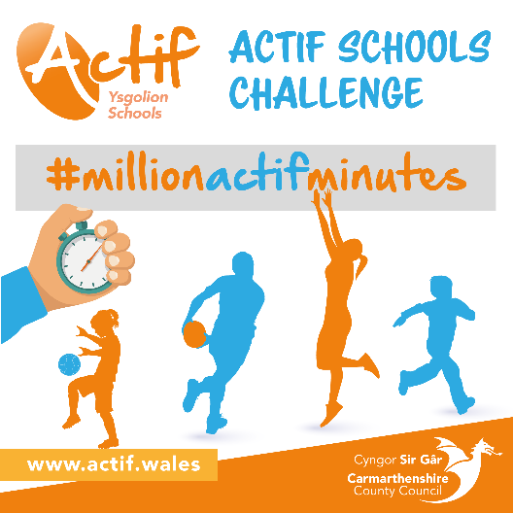

**The Actif Schools Challenge welcome pack!**

**#millionactifminutes**

Launch date: 1/02/2021

End date: 28/02/2021

**Your schools’ target:**

We have calculated your schools target in comparison with how many students you have within your school.

**Here is what you need to know**:

We would like you and your school to get on board with our County Wide initiative of #millionactifminutes and inspire your students to contribute to the overall 1 million minutes of activity. Through this project we would like all students to take a break from their screen and take part in activities of their own choice. Following on from this we would like you to then record the minutes of activity completed via the link below. The survey below will automatically be submitted to our Actif team where we will then calculate and keep track of how many minutes your school has achieved.

**Here is the link for you to share with your pupils, the survey will simply need to be completed once you have completed exercise:**

<https://app.upshot.org.uk/survey/a876f989/621/17549bca/>

**Visit our web page to see our activity resources:**

<https://www.actif.wales/community-sport/children-and-young-people/actif-schools-challenge/#Activity>

**Don’t forget to share your schools’ journey with us on social media, as we would love to see your progress!**

 **Good Luck!**

 @Sportcarms

Actif Sport & Leisure