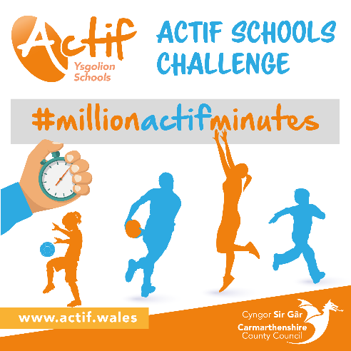

**The Actif Schools Challenge welcome pack for**

**Parents!**

**#millionactifminutes**

Launch date: 1/02/2021

End date: 28/02/2021

**Here is what you need to know**:

We would like you to get on board with our County Wide initiative of #millionactifminutes and inspire your child to contribute to the overall 1 million minutes of activity. We understand that times are testing and a lot more is expected from parents and guardians than usual. Through this project we would like all students to take a break from their screen and take part in activity of their own choice. Following on from this we would like you to then record the minutes of activity completed via the link below. The minutes will then be added to your schools’ target.

**How can you help?**

Help and remind your child to fill in there completed minutes

Promote and encourage your child to participate in the challenge

JOIN IN!

**Here is the survey you will simply need to complete this once you have completed exercise:**

<https://app.upshot.org.uk/survey/a876f989/621/17549bca/>

**Visit our Web Page to discover some ideas**

<https://www.actif.wales/community-sport/children-and-young-people/actif-schools-challenge/#Activity>

**Don’t Forget to share your journey to achieving your minutes online and tag us on:**

**@sportcarms**

**Good luck!**